

**BEGINNERS CLASSES:**

MONDAY & WEDNESDAY 4.15-5PM

TUESDAY 4-PM

SATURDAY 9.15-10.15AM

Sovereign Gymnastics & Trampolining Club

CLUB TIMETABLE & CLASS INFORMATION

**NOVICE/INTERMEDIATE CLASSES:**

MONDAY 5.15-6.15PM

TUESDAY 5-6PM

SATURDAY 10.15-11.15

BOYS ONLY: WEDNESDAY 5.15-6.15

INVITE ONLY: THURSDAY 4-5PM

FREE TRIAL

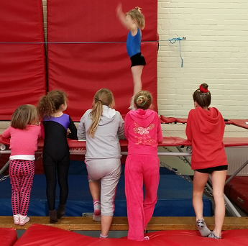

**TRAMPOLINING CLASSES:**

EVERY HOUR BETWEEN THE BELOW TIMES:

FRIDAY 4.30 - 7.30PM

SATURDAY 9.15AM - 13.15PM

MIXED AGE & ABILITY CLASSES.

**ADVANCED CLASSES:**

FRIDAY 4.30-5.30

SATURDAY 11.15-12.15

BOYS ONLY:THURSDAY 5-6PM

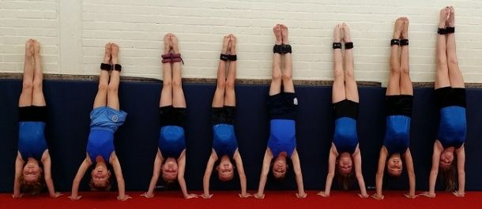 

**BLOCKS AND TUMBLING CLASSES:**

(INVITE ONLY)

MONDAY 5.15-7.45PM

TUESDAY 5-7.30PM

WEDNESDAY 5.30-8PM

SOFT PLAY MORNINGS:- TUESDAY, THURSDAY & FRIDAY 9.30AM - 1PM

TEENY TINY LASTICS:- MONDAY AND WEDNESDAY MORNINGS 11AM FOR 30-40 MINS

LITTLE LASTICS PRE SCHOOL CLASSES:- MONDAY AND WEDNESDAY 9.30 - 10, 10.15 - 10.45

**SQUAD:**

INVITE ONLY.

BLOCKS, TUMBLING, ACRO & INDIVIDUAL CLASSES.

**SCHEMES AND SPECIFIC CLASSES:**

MYCLUB: TUESDAY 6-7PM

PARKOUR: THURS 6-7 & 7-8PM

RETIRED GYMNASTS AND ADULTS: WED 7.30-9PM!

AGED 11+ FOR ABOVE CLASSES